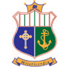 Scoil Mhuire Ethos & Mission Statement 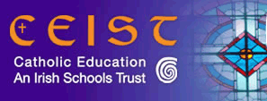

“Scoil Mhuire is a Christian, caring community which encourages the integrated
development of every individual concerned.”

Every member of this community - teachers, students, staff, and parents - feels a sense of commitment and belonging.

Scoil Mhuire is under the trusteeship of CEIST – the Catholic Education Irish Schools Trust. CEIST is the trustee body for the voluntary secondary schools of the Daughters of Charity, the Presentation Sisters, the Sisters of Mercy, the Sisters of Christian Retreat and the Missionaries of the Sacred Heart.
The Vision of CEIST is to create a compassionate and just society inspired by the life and teachings of Jesus Christ. Its Mission is to provide a holistic education in the Catholic Tradition.
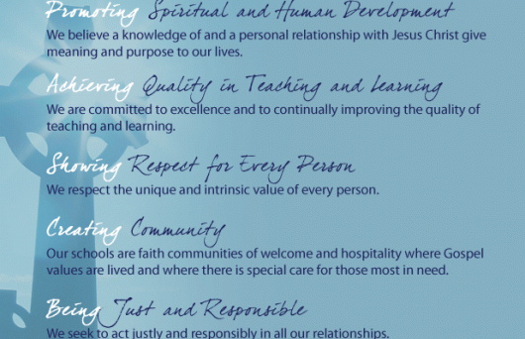
The CEIST community is committed to living the vision and the core values of the Charter. These values have their roots in the Gospel of Jesus and have been central in the tradition of the five founding Congregations. CEIST schools are committed to value-led education and the curriculum is underpinned by the values of Jesus Christ.

School Policy List
- Acceptable Internet & Social Media Use  - Admissions & Enrolment  - Anti-Bullying  - Attendance  - Child Safeguarding  - Critical Incident Response Plan - due for review  - Data Protection/GDPR  - Digital Learning Plan – in progress  - Dignity at Work  - Extra-Curricular Activities  - Guidance Plan – under review  - Healthy Eating | - Health, Safety & Welfare  - Homework  - Job-Sharing  - Learning Support  - Pastoral Care  - Relationship & Sexuality Education  - School Code of Behaviour – under review  - School Trips  - SEN  - Substance Use/Misuse  - Teaching Placement  - Visitors to the School  - Vetting

Message from the Principal
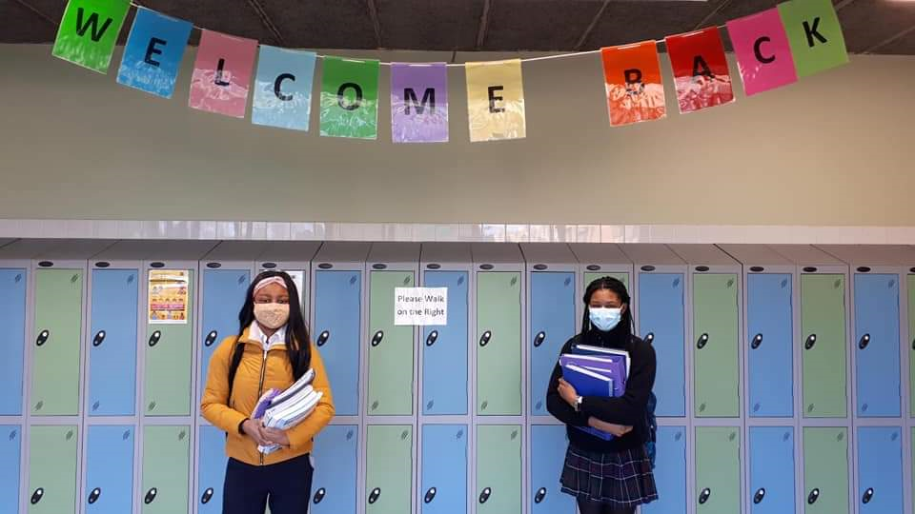

The school year 2020-2021 has been a year like no other! We returned to school in August grateful for the tremendous work done by teaching, caretaking, secretarial & housekeeping staff to prepare the school for reopening in the midst of the pandemic. With sanitiser at every doorway, new systems of working, obligatory mask-wearing and social-distancing, the prospect was daunting for many. I am deeply grateful to our staff, students and parents for the many ways in which they demonstrated solidarity, resilience, kindness and generosity to each other throughout the year. To our wonderful staff I say thank you for your daily commitment to your students, your good humour in the face of many challenges and above all, your support for each other. Despite many restrictions, our committed staff found novel ways to deliver the curriculum and extra-curricular experiences and activities to all.
Critical to the delivery of quality teaching & learning this year was the availability and uptake of online learning during periods of school closure. Investment by the Board of Management in teacher devices was matched by teacher investment of their free time and energy in adopting new practices, upskilling in technology and sharing new learning with colleagues and students. Thank you to Ms. Guerin, our Deputy Principal who co-ordinated the supply of devices and SIM cards to students during school closure and to 3Ireland who provided free SIM cards for students during that time. Teachers built on the experiences of the March – June school closure in 2020 and feedback from students, parents and staff was that their experience of school closure and online learning was much improved in the 2020-2021 school year. First Year students were tutored by teachers at the outset of the school year on the use of the Microsoft Teams platform and the introduction of Digital Literacy classes each week for the First Year group ensured greater confidence when schools closed after Christmas.
We think of all members of our school community who experienced bereavement during this school year. The loss of a family member is profoundly sad at any time; bereavements in the past year were even more sharply felt. May all those who have died rest in eternal peace and may their loving families find consolation and strength in happy memories of times past.
Despite the many restrictions and curtailments caused by Covid19, there were many occasions of joy and achievement in our school. Thank you to our students and staff for creating these bright moments throughout the year. You will, I hope, get a sense of these happy events in the following pages. There were many moments of anxiety and fatigue this year, but they were greatly outnumbered by the occasions where people showed compassion and courage; resilience and strength; forgiveness and fun.
Thank you to our Board of Management for steering us through this year. The voluntary work done by members of the Board on behalf of the school community is invaluable and we thank them for generously giving of their time and energy to govern the school. Sincere thanks also to our Parents’ Council for dedicating your time to work in partnership with the school for the good of our students.
Upgrading and reconfiguration of the Art Room is planned for the summer months of 2021. An application for grant-aid to upgrade the Outdoor Courts was made in March 2021 to the Department of Tourism, Culture, Arts, Gaeltacht, Sport and Media. The assessment of applications is underway and we hope that Scoil Mhuire’s application will be successful. Local fundraising towards this project will commence in September 2021.

We are all now so familiar with the phrase “We’re in this together!” over the past year. It is certainly true of the Scoil Mhuire community where the partnership, collaboration and mutual support of students, parents, staff, Board of Management and Trustees combine to create a happy and successful school. Thank you to everyone for your commitment to our school.
Scoil Mhuire Board of Management

The school is governed by a Board of Management appointed by the Trustees – CEIST. We are grateful to the members for generously giving of their time and knowledge to manage the school.
The Board has the overall responsibility for the management & governance of the school. The Principal Ms. Mary O’Keeffe is Secretary to the Board and is responsible for the day-to-day administration & management of Scoil Mhuire. Ms. Agnes Guerin acts as Recording Secretary to the Board of Management
Trustee Nominees | Parent Nominees | Teacher Nominees
Michael O’Brien (Chairperson)  John Butler  Sr. Veronica Casey  Sinéad Glascott | Stephen Croke  Margaret Keane | Catherine Nyhan  Neelu O’Sullivan

Although the activities of the Parents’ Council were somewhat curtailed by public health restrictions, the Council met remotely on a number of occasions throughout the year, led by the Chairperson Angela Watson.
The initial focus of activity was on student wellbeing and mental health and to that end the Parents’ Council secured the services of psychotherapist Tara Morrissey. The presentation on anxiety given at the Parents’ Council AGM by was very informative and interesting. Ms. Morrissey also presented to staff and students before Christmas and the session was deemed practical, useful and most welcome. Appreciation was expressed to Narrell Byrne for organising the delivery of these sessions for the school.
Sincere thanks to the Parents’ Council for providing prizes for the ‘Spring Into Action’ initiative that was organised by Ms. O’Connell during school closure January – March. Teams of 4 (students, family members, friends) completed and recorded 60 km per week with a draw held each fortnight for all teams reaching their target. This initiative aimed to promote wellbeing and connectedness during the period of restrictions and was a huge success. Congratulations to all involved.
Parent Teacher meetings did not take place in 2020-2021. Extended reports were issued to all parents, and telephone contact was made with parents as required. Information evenings for Transition Year, Senior Cycle, and CAO etc took place online.
Following the period of school closure March-June 2020, online surveys of staff, students and parents provided valuable information to inform school planning for subsequent closure.
Lessons for all students o the Teams platform were scheduled for August & September 2020. Teams were again formed for all subject groups and staff committees. All staff members were provided with a device and training to enhance the delivery of remote classes.
Lessons for all students moved online after Christmas.
All communication including teaching & learning was conducted via the Microsoft suite of applications which is fully encrypted and complies with data processing regulations.
Parents were advised of remote teaching & learning procedures and guidelines by electronic means.
Students were facilitated to collect books and other materials. SIM cards were distributed to those with poor internet access and tablets/laptops were made available to many students.
SEN students had a dedicated contact teacher throughout the period of school closure. Our SNA continued to work with students on an individual basis through Microsoft Teams providing emotional support and continuing with typewriting skills development.
Pastoral Care supports for students continued throughout the period of school closure, with contact from Year Heads, class tutors, Guidance Counsellor, middle and senior management via Microsoft Teams.
Ms. O’Grady operated the Guidance counselling service remotely and all Leaving Certificate students were supported with applications to CAO, UCAS, PLCs, HEAR & DARE access programmes.
The teaching staff of Scoil Mhuire did outstanding work throughout periods of school closure. Peer to peer in-service took place remotely to enhance the online teaching and learning experience. A high-quality blended learning programme was delivered to all students.
Student wellbeing was very much to the fore throughout. Ms. O’Connell conducted weekly online exercise classes in various disciplines that were hugely beneficial to all members of the school community from a physical and social wellbeing perspective.
Parents reported logging in with their daughters to cookery demonstrations given by Mrs. Holden and Ms. Nyhan and were very appreciative of the opportunity to get involved in preparing dishes as a family activity.
The return to in-school teaching & learning in March and April 2021 was a welcome development for all with many valuable lessons learned in the online space. Staff and students continue to utilise the benefits of technology to enhance teaching & learning, communication & collaboration.

Covid Response
The first return to school sine 12 March 2020 took place during the last week in August with induction of staff and students. The Covid Response Plan ratified by the Board of Management provided the roadmap for reopening our school. Our Covid Aides Ms. Foley and Ms. Murphy ensured that everything was in place for a smooth reopening. Zoom presentations for parents and students in advance of reopening gave reassurance to all and great credit is due to everyone since then for their efforts in maintaining physical distance and observing all of the necessary hygiene protocols.
The Covid Response Committee has met twice since August 2020. Procedures and systems outlined in the Response Plan worked well throughout the year with regular reminders about social distancing and hygiene protocols. The Lead Worker Representatives J. Foley and T. Dineen monitored implementation, acted as staff point of contact and liaised with senior management on behalf of the entire staff throughout the school year.
A Department of Education & Skills inspection of Covid measure in the school took place on 22 October 2020. The school was certified by the Inspector as being fully compliant will all Covid Prevention and Child Safeguarding measures contained in the inspection schedule.
We are very grateful to our housekeeping staff that completed additional cleaning and sanitising on a daily basis to ensure the health & safety of the school community.
The Covid Minor Works Grant provided to the school by the Department of Education & Skills enabled classrooms to be reconfigured and the purchase of additional equipment for practical subjects where sharing of equipment is restricted.
Prevention measures and procedures will continue in the 2021-2022 school year.
Below are some samples of student work submitted in response to Covid19:
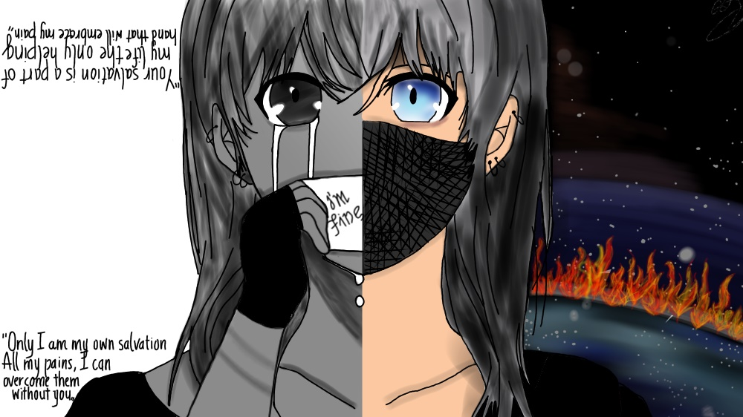

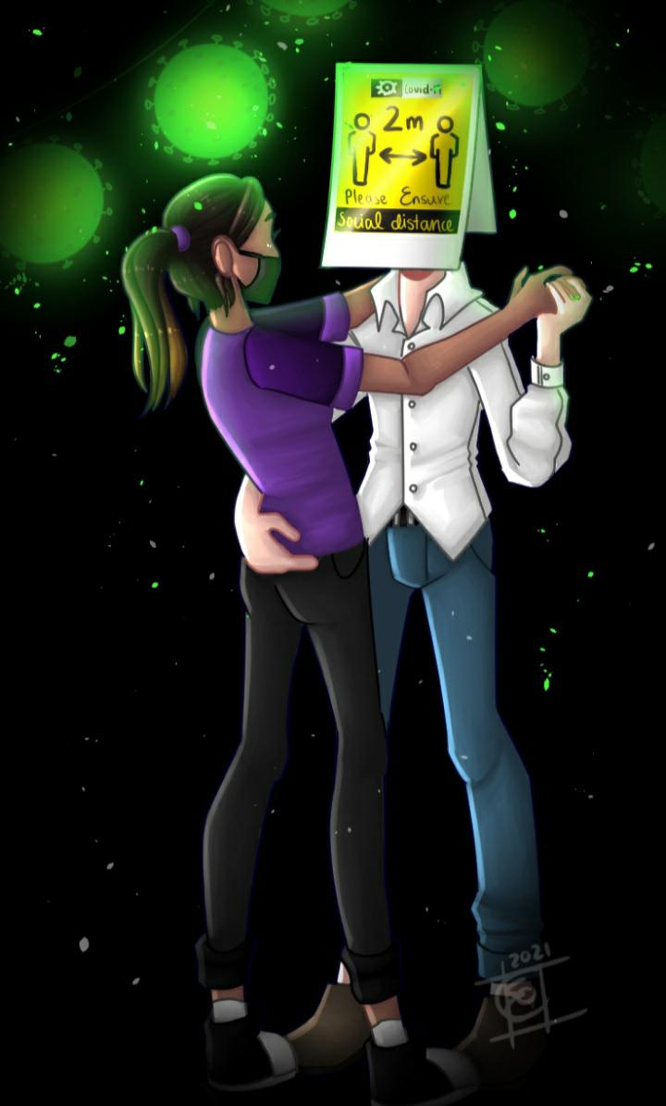
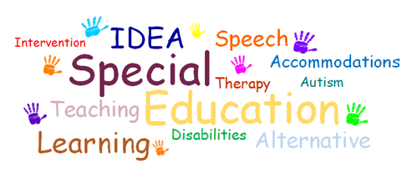
39 students availed of additional support during the 2021-2021 school year. Supports delivered by teachers and SNA included:
- Literacy & Numeracy support
- Study Skills
- Mind-mapping
- Managing Anxiety & Stress
- Typing Tuition & Assistive Technology support
- Organisational Skills
- Social Stories
19 teachers were involved in the delivery of Special Education and Resource classes, under the guidance of the SEN co-ordinator Ms. Denby.
The SEN Team comprised Ms. Denby, Ms. Pringle, Ms. Murphy, Ms. Comerford with support from the Principal, Deputy Principal & Guidance Counsellor, Ms. O’Grady. A Statement of Roles & Responsibilities of the SEN Team was ratified by the Board of Management.
In addition to class support, testing of students for Reasonable accommodation in the Certificate Examinations (RACE) took place during the year.
The NEPS Psychologist attended the school to perform educational assessment with a number of students and NEPS also provided a targeted and intensive one-to-one programme of support for an individual student.
Our SNA provided much-needed support and reassurance for individual students experiencing periods of stress and anxiety. This support continued throughout periods of school closure with weekly meetings online.

Provision made for SEN Students:

- Resource teaching hours
- Learning Support withdrawal
- Individual Pupil Learning Plans were prepared and updated.
- Sen Co-ordinator provided guidance and advice to SEN teachers throughout the year.
- SEN materials uploaded to school database to enhance teacher access to recommendations.
- Personal, educational & vocational counselling with School Guidance Counsellor
- Support from School Chaplain
- SNA support – emotional care, organisational support, Typing tuition.
- SEN is an agenda item at weekly Student Support Team meetings attended by Chaplain, Guidance Counsellor, Deputy Principal, Principal, SEN Co-ordinator.
- The SEN team was formed, with training in WRAT testing for RACE provided by the Co-ordinator to members of the team.
- Weekly Homework Club provided on a voluntary basis by Ms. Pringle for 1st & 2nd Years.
- Applications were made for Assistive Technology.
- Referrals were made to the National Educational Psychological Service (NEPS).
- Reduced timetables were permitted for a small number of students experiencing chronic fatigue and emotional disorders.
- The Home Tuition Scheme was utilised during this year.
- Team teaching was not possible this year due to prevailing health guidance.

Transition Year
Huge thanks to Ms. Healy and the TY teachers for co-ordinating an interesting, challenging and inspiring TY programme despite the Covid restrictions. Students were lucky to have so many varied experiences, from Stand-Up comedy to Etiquette, Drumming to Poetry. Below is a taste of the additional activities and experiences offered to TY students this year – this list is not exhaustive.
- Accounting Bootcamp
- Ballyhass Adventure & Team-Building Day
- Breast Cancer Ireland Awareness Workshop
- College Open Days
- GAA Future Leaders Programme
- Health Fest
- Healthy Living Week
- Inspireland Poetry Workshop
- iWish Conference
- Mandala Workshop
- Online pancake & pizza-making masterclasses
- RCSI Mini-Med Course
- Road Safety & Driver Theory Test
- Shona Project SHINE Festival
- Sign Language (thanks to Nicole – a
TY student!)
- ‘Stand Up’ Week
- St. Joseph’s Shankill Dementia
Workshop
- Young Social Innovators
- Zumba Workshop
This year a Management Committee for Transition Year was set up from a group of interested students. This dedicated team of students regularly gave up their lunchtimes to organise activities and give extremely valuable input on the running of the programme. Under the guidance of Chairperson, Kerry O’Mahony they cooperated with the TY Co-ordinator to plan and organise activities and experiences for the TY group and the extended Scoil Mhuire school community. Well done to all involved!
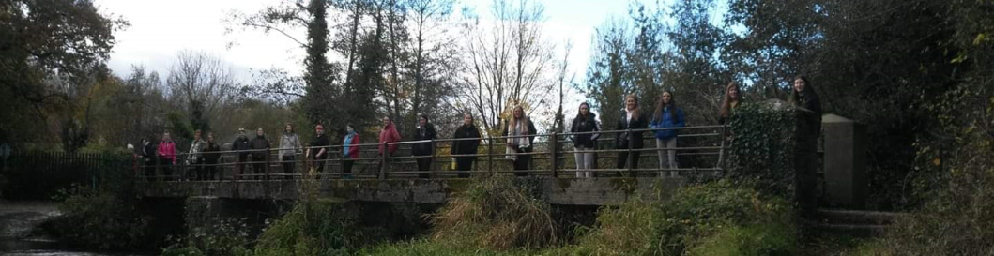
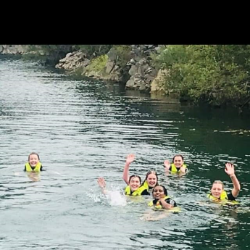
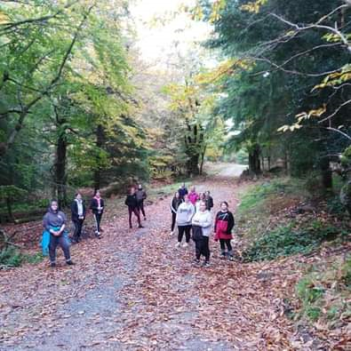
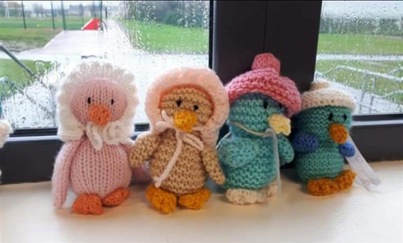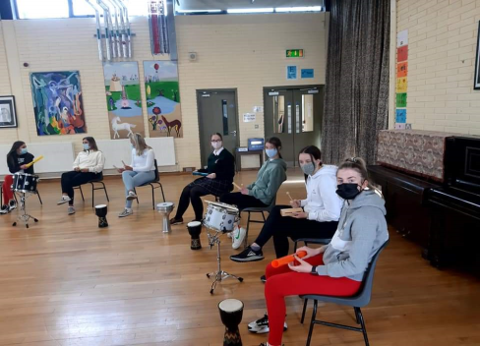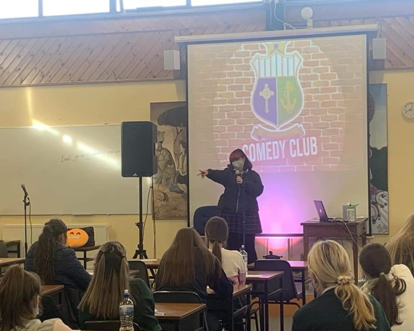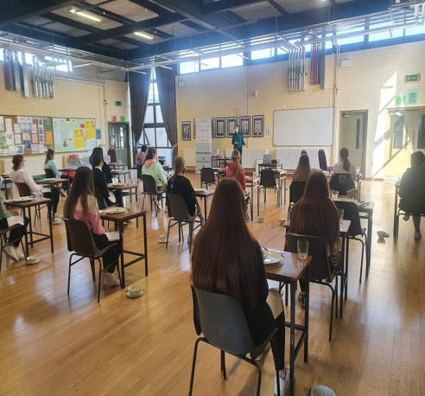
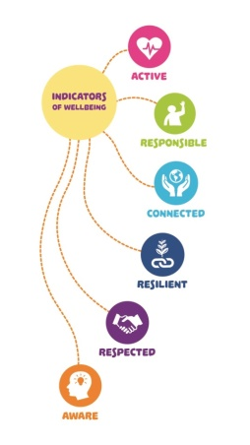
Wellbeing
Ms. Donohoe co-ordinated the Wellbeing programme throughout the year in her capacity as Leader of Wellbeing in Scoil Mhuire. Staff members and students contributed to improving our individual and group sense of health, happiness and wellbeing.
The individual indicators of Wellbeing were emphasised during Term 1 with a focus on awareness and opportunities for action.
Surveys of various groups in the school community yielded data to inform future actions.
The Young Social Innovators (YSI) group in Transition Year – ‘Have a Heart’ concentrated on raising awareness and spreading happiness and positivity throughout the school with visual displays, Spotify playlists and random acts of kindness.
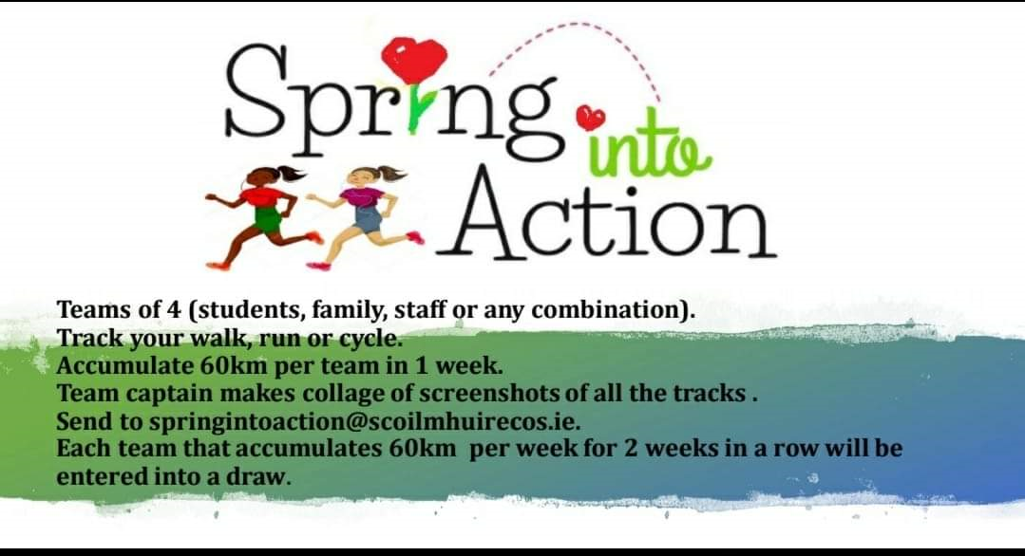

Ms. O’Connell’s ‘Spring into Action’ was a huge success, involving teams of 4 in exercise, connectedness and wellbeing throughout the period of school closure after Christmas. This initiative, coupled with the exercise classes that Ms. O’Connell delivered on a weekly basis, provided much-needed motivation for many members of the school community.
Ms. O’Grady, Guidance Counsellor, provided wellbeing advice and support for students and staff as did our school chaplain Ms. Jones.
The Student Council worked throughout the year to support the various wellbeing activities and initiatives that took place.
Christmas Movie Mornings, organised by Ms. Shanahan and supported by staff and students, raised funds to purchase picnic tables to provide much-needed additional outdoor seating. Further outdoor furniture was kindly sponsored by Celtic Hose Ltd.

Healthy Living Week, co-ordinated by Ms. Nyhan, received great support from the school community. From healthy foods to physical exercise, meditation to mindfulness, there was something for everyone!
Staff of the school was reminded that Spectrum Life operates the Occupational Health and Wellbeing strategy for the public service, with many online resources available to all.
‘Stand Up’ Week provided an opportunity for everyone to show support and respect for members of the LGBTQI community in our school and beyond. Included in the week’s activities were daily reflections on the intercom, visual displays and the design and making of rainbow facemasks, culminating in a world record attempt for the most people in one place wearing rainbow masks! Well done to Ms. Cummins, Ms. O’Grady, the Student Council, all of their helpers, and the entire school community who backed the initiative.
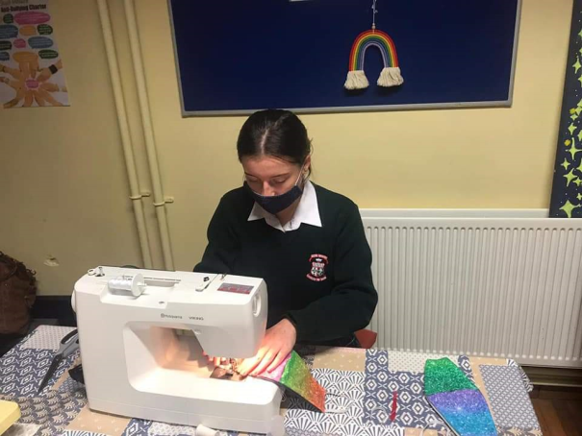
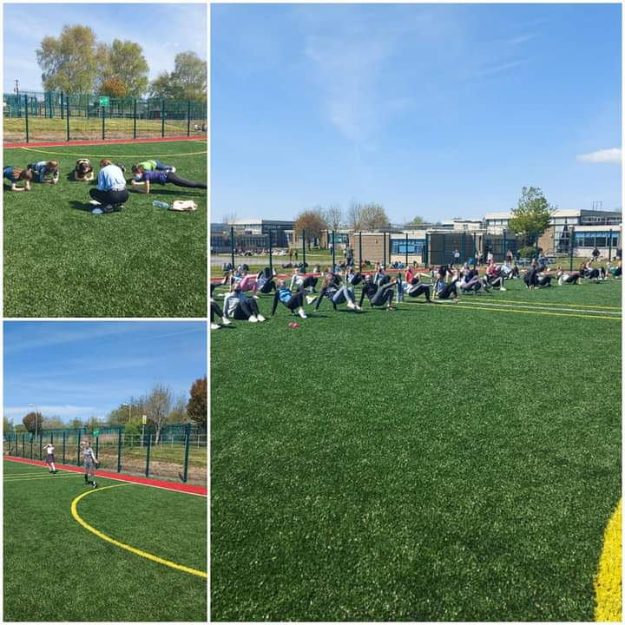
Active Schools’ Week involved a blend of physical activity during PE class time and additional activities provided during lunch break. Fortunately, the weather obliged, and many events and activities took place under sunny skies.

Fitness Snakes & Ladders proved to be hugely popular with everyone as evidenced by the pictures below:

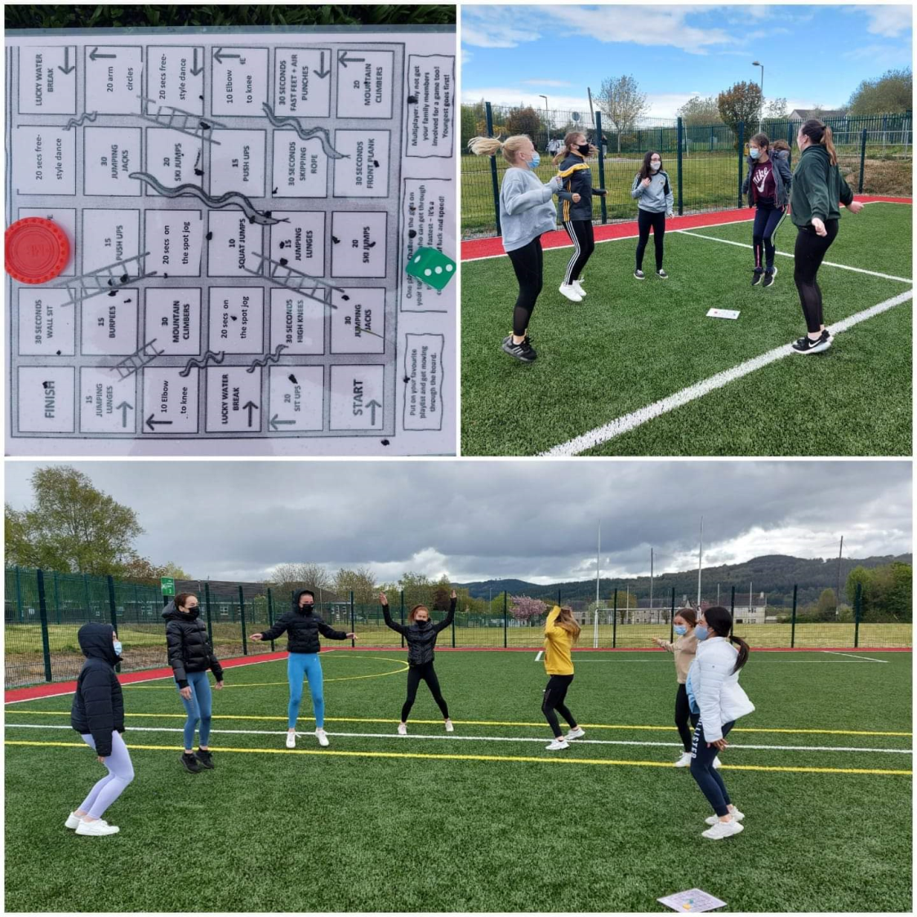

Despite Covid restrictions, there is always fun to be had in Scoil Mhuire. Dress-Up Day for Hallowe’en provided much-needed respite for everyone with a parade of costumes delivering an injection of relaxation for all.
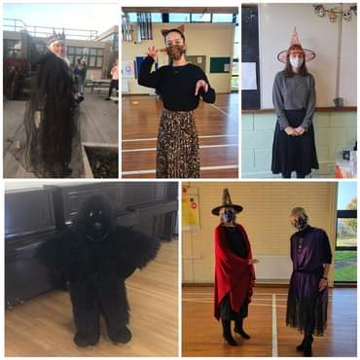
Sixth Years, deprived of the many milestones that normally occur in their final year, came to school in disguise in the last week of May – see the cast of ‘Grey’s Anatomy’ below!
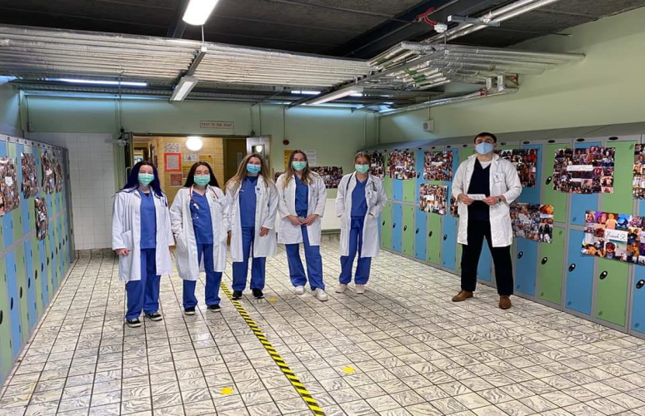
Many opportunities for outdoor activities presented themselves this year – cycling the Blue way to Clonmel, the Tipp Tik Tok Challenge and the TY Teddy Bears’ Picnic, to name but a few!
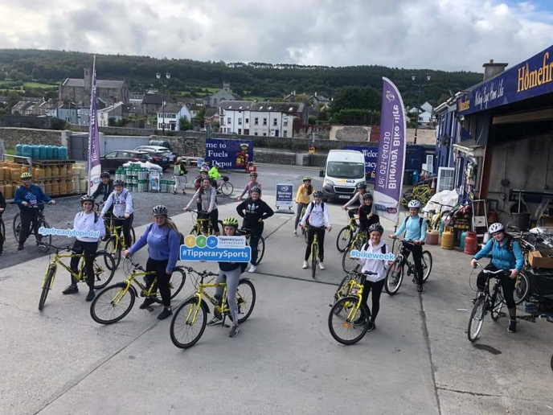
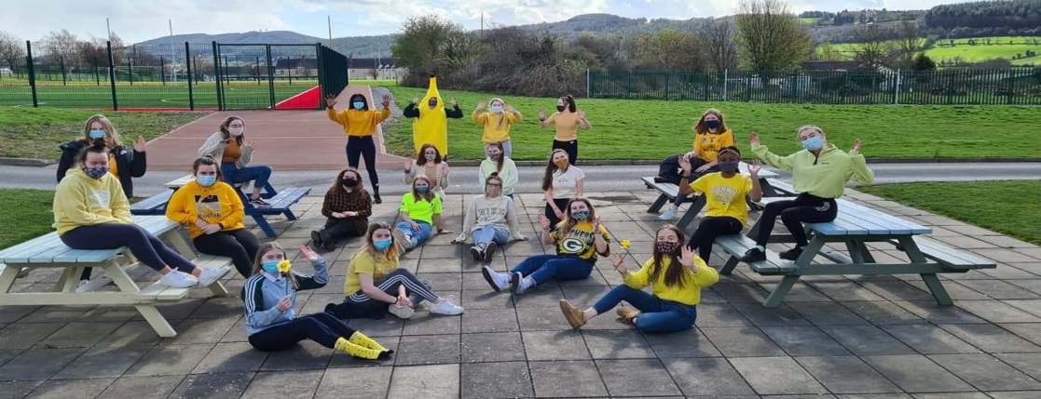
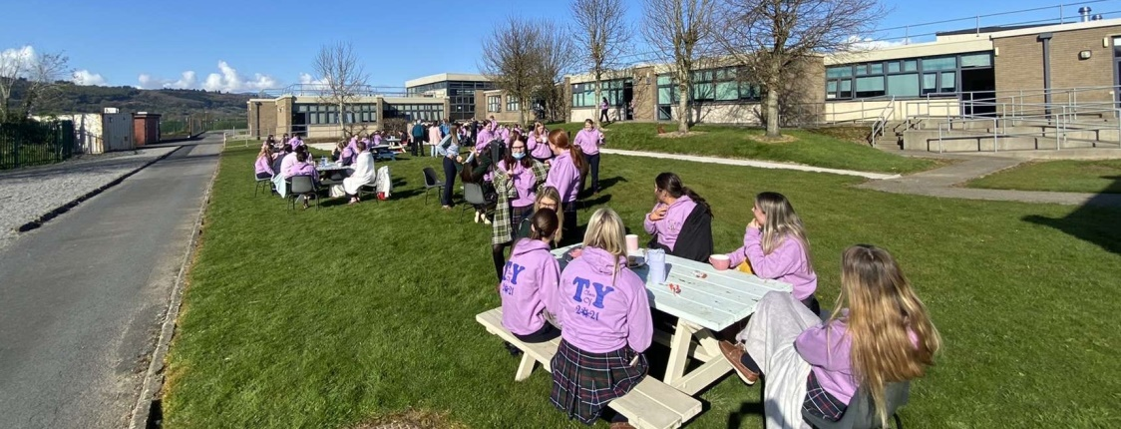
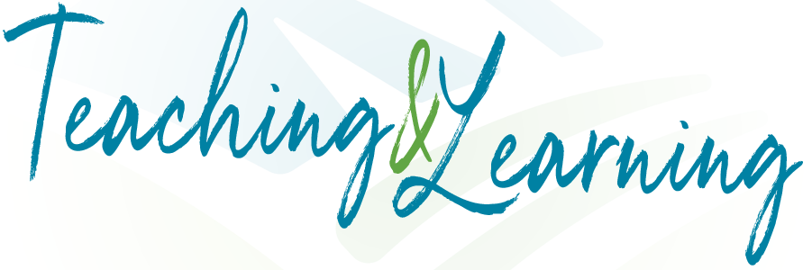
The priorities for 2020-2021 were a smooth return to in-school teaching & learning; contingency planning for further school closure and development of IT infrastructure and teacher & student IT skills, confidence and competence.
Teams for every teaching group, year group and staff working group were set up on the Microsoft Teams platform.
Tuition on the use of Teams was provided to students in the first two weeks of the school year.
External and internal staff training in the platform continued during the school year, with further PDST training to be provided in August 2021.
A single period of Digital Literacy was introduced for First Year students as part of the delivery of 400 hours of Wellbeing. The teachers involved – Ms. Foley, Ms. Greene & Ms. Healy – delivered a programme focused on equipping all First Years with the skills and knowledge to use IT as a tool for learning, research and submission of their work.
During this time students were introduced to the Microsoft office 365 space. Through Teams, students created work on the online platform. Internet safety, wellbeing, educational platform- appropriate language/formal conversation versus social media also featured in order to create the right educational culture for their online space.
Support for the Digital Literacy Team was provided by PDST through a blend of webinars, remote sessions with a PDST advisor and planning time. This support will continue in the 2021-2022 school year.
Surveys of students and parents took place to evaluate levels of access to internet/a device at home. When school remained closed after Christmas, devices were distributed to students from the school, with priority given to exam students. SIM cards provided free of charge by 3Ireland were distributed to students experiencing difficulty accessing internet at home. We are very grateful to 3Ireland for this wonderful support that supported equality of access to all our students.
Contingency planning for school closure was tabled for discussion at a staff meeting in November 2020. Among the items explored were the local and national context; learning from research on the 2020 school closures; developing an agreed approach to online teaching & learning; professional development needs; infrastructure requirements.
Through the ICT grant provided by government, all staff members were provided with a teaching device. Training in the use of devices was initially provided externally but moved to an in-house model through tremendous levels of teacher collaboration and peer-tutoring. The provision of teacher devices released additional devices for student use during school closure.
Feedback from students, teachers and parents in relation to online teaching & learning in 2021 was overwhelmingly positive. The blended approach of live and pre-recorded class materials agreed by staff in November 2020 was welcomed by all and it was generally felt that this second period of school closure, though challenging, was hugely successful in terms of teaching & learning.
Further development of the school’s Digital Strategy will continue in 2021-2022.

Religious Education in Scoil Mhuire aims to support the spiritual development and faith formation of students. Inspired by the vision of Catherine McAuley, Scoil Mhuire seeks to foster the integrated development of every student in an inclusive, respectful and happy environment. Students are given opportunities for learning, discussion, reflections, debate and meditation. In the 2021-2021 school year, all year groups apart from Transition Year had 3 periods of Religious Education per week. In the 2021-2022 school year, provision for TY will extend to 3 periods per week.
Students follow the non-examination curriculum in class and encounter opportunities for charitable and social justice programmes throughout the school year. The liturgical year and additional school celebrations offer students opportunities for involvement and participation.
The temporary loss of the school Prayer Room was keenly felt by all members of the school community and we look forward to the time when public health advice will enable us to again use that space for prayer, reflection, meditation and liturgy.
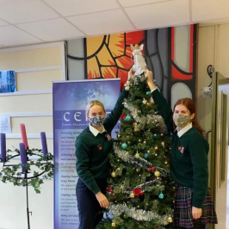
Formal celebrations of faith were very limited in the 2020-2021 school year. Mercy Day was marked with a remote prayer service. The Annual Christmas Carol Service also moved to the online space, with a pre-recorded broadcast from St. Nicholas’ Church in Carrick on Suir. We are grateful to Mrs. Sullivan, the RE Department and the Sixth Year students for providing this online service for the school community. The Advent and Christmas seasons were marked with a daily ‘Action for Advent’ in addition to the annual display of the Advent wreath, Jesse Tree and Crib.
Transition Year students co-ordinated two important appeals during the year. Assisted by Ms. Nyhan, they organised care packages for elderly residents of local nursing homes, many of whom had been unable to see loved ones for many months. The kindness and generosity of the school community was evident in the many items donated.
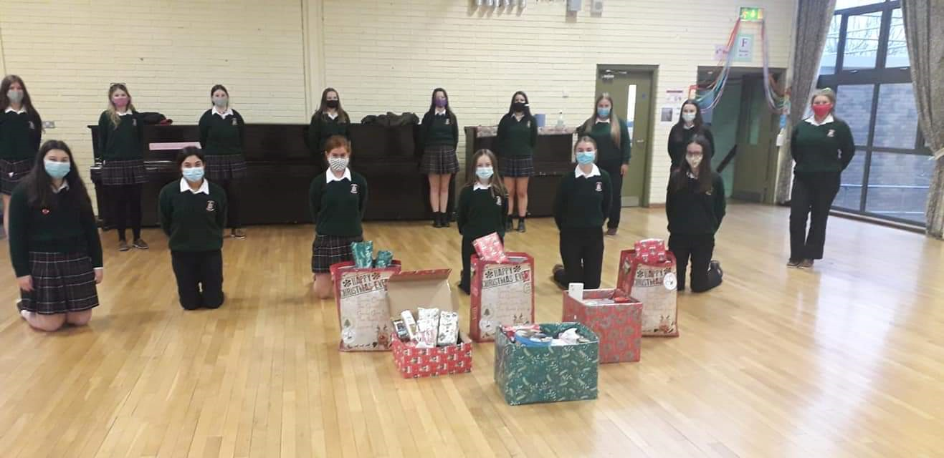
One of the many effects of the pandemic has been the loss of income to charities. In April & May 2021, Ms. Nyhan and TY students co-ordinated a collection of clothing / household textiles for the Society of St. Vincent de Paul. Many thanks to all families associated with the school for your kind donations.
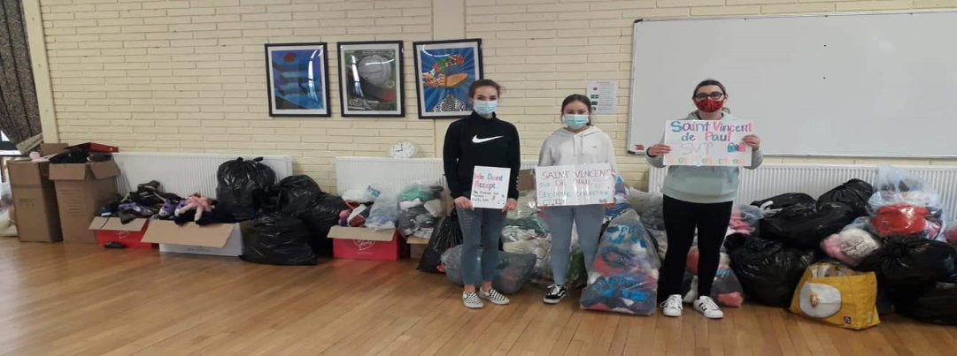
Young Social Innovators
Young Social Innovators (YSI) is a non-profit organisation that empowers young people to use their talents, insights, passion and creativity to come up with innovative solutions to social challenges. Through fun and engaging programmes, students are supported to create team-based action-projects on issues they care about, putting their innovative ideas into action to bring about positive social change for the benefit of people, communities and the environment. The YSI Programme was delivered by Ms. Doran to Transition Years in 2020-2021.
The Meitheal Programme
Fifth Year students act as mentors to First Years to assist them in their transition to secondary school and to provide them with opportunities to develop friendships and skills and a feeling of belonging to the Scoil Mhuire school community. Ms. O’Connell co-ordinated the programme, and the year began with the selection of Meitheal leaders and initial training. These Meitheal leaders acted as role models and ‘big sisters’ to First Year students, organising events and activities throughout the school year. They also participated in a remote Information Evening for incoming First Year students and their parents.
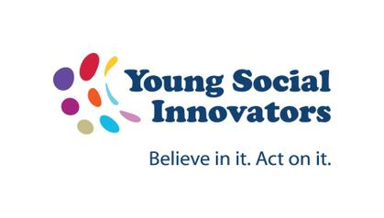
Green Schools’ Committee & Climate Justice
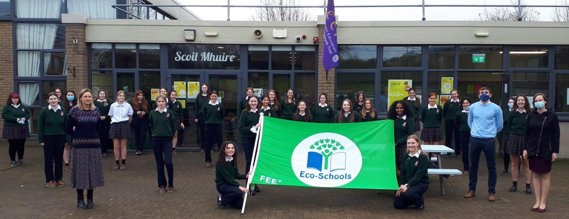
Green-Schools is Ireland’s leading environmental management and education programme for schools. Promoting long-term, whole-school action for the environment Green-Schools is a student-led programme with involvement from the wider community. The programme is operated and coordinated by the Environmental Education Unit of An Taisce. Scoil Mhuire has an active Green Schools’ Committee which was awarded its green flag in 2020 for litter & waste management, including recycling. In the 2020-2021 school year, the theme was energy awareness. Ms. Marshall co-ordinated a collection of used batteries and a collection of electrical equipment to raise awareness and promote sustainable recycling of electrical waste.

World Wise Global Schools
WWGS has been a feature of Scoil Mhuire for many years and will feature as a timetabled module in Transition Year 2021-2022. Global Citizenship Education (GCE) is an educational process aimed at increasing awareness and understanding of the rapidly changing, interdependent and unequal world in which we live. By challenging stereotypes and encouraging independent thinking, GCE helps students critically explore the root causes of global justice issues and how they interlink with our everyday lives.
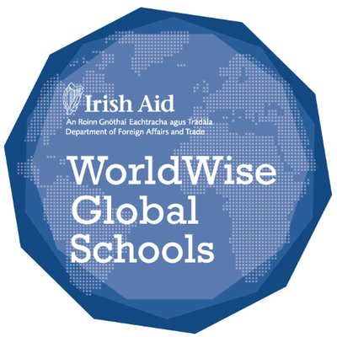
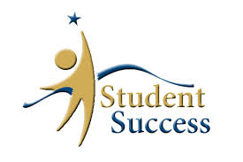
Student Achievement
Congratulations to all of our students on displaying great courage, resilience, determination and kindness throughout the year!
The Class of 2020 is commended on their achievements – 97% of the group has progressed to Third Level in what was a most challenging time. Congratulations and best wishes to our Class of 2021 who had the option of Accredited Grades and the State Examinations this year.
Congratulations to:
- Meadhbh Houlihan of the Class of 2020 who received a TCD Entrance Exhibition Award.
- Caoimhe O’Connell (Class of 2019) who received The Anne Crookshank Prize in Trinity College Dublin which is awarded to the Junior Freshman student who gains the highest mark in the annual summer examination in the History of Art.
- Issy Boxwell (TY) who was selected on the shortlist for the Young Animator of the Year Awards 2021.
- Muireann Shortiss Day (3rd Year) who was highly commended in the Texaco Art Competition 2020
Mrs. Holden co-ordinated the Student Awards in Scoil Mhuire for 2020 and 2021. Congratulations to the 2020 Student of the Year: Ellie O’Dwyer and the recipient of the CEIST award 2020: Lorna Butler.
Congratulations to students who received Class Spirit Awards in May 2021:
1 Aisling Caoimhe O Donnell  1 Aine Mia Dunphy  1 Amelia Brid Fogarty  2 Barbara Rebecca Robinson  2 Brid Jade Barry  2 Brenda Eva McMahon  3 Caroline Emma O Neill  3 Cliona Aoibhe Shankey  3 Clare Tara Peters | 4 Deirdre Kendra Watson  4 Denise Sarah O Keeffe  4 Doirin Amelia O Toole  5 Edel Amy Cullinane  5 Eithne Natifah Coughlan  5 Emer Abbie Power  6 Fidelma Amy Power  6 Finola Lindsay Atim  6 Fiona Meg Hennebry

Congratulations to the 2021 Student of the Year Caitlyn Kiely and the CEIST Award winner Niamh McKnight.

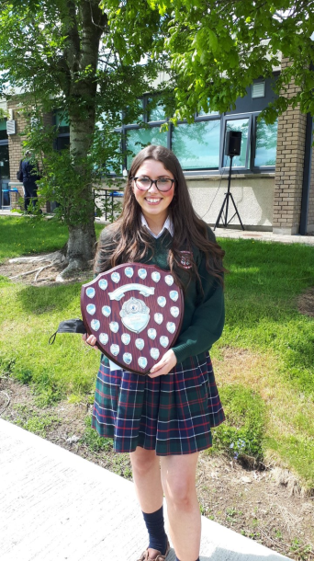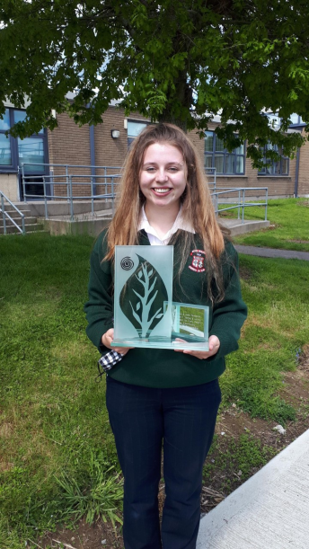

The Board of Management is grateful to Carrick on Suir Credit Union for its annual sponsorship of the Student of the Year. John Power and John Casey represented CCU at the presentation of Awards in May 2021.

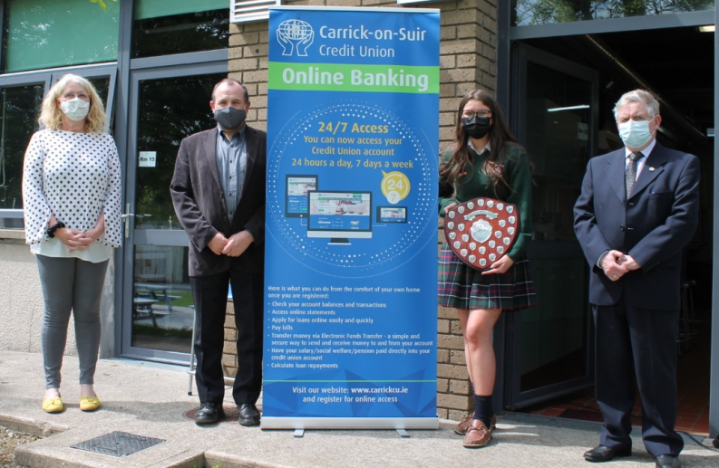
We were very excited to have 5 past-pupils representing Scoil Mhuire on the Kilkenny Senior Camogie team – All-Ireland Champions 2020 and League Champions 2021. Congratulations and Well Done!

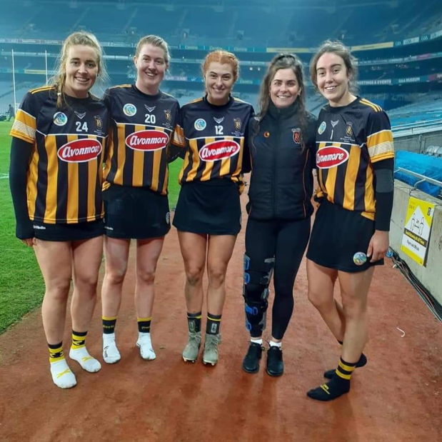

Well done to Jane O’Keeffe who was a performed so well in the European Money Quiz.
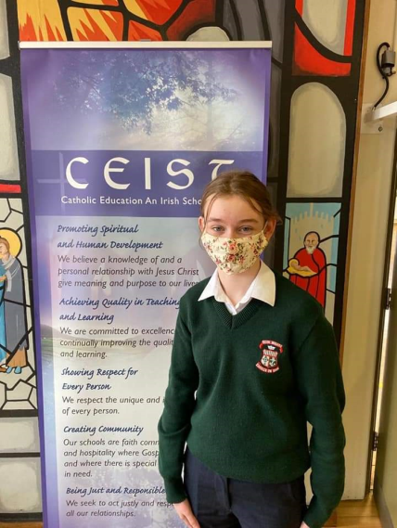

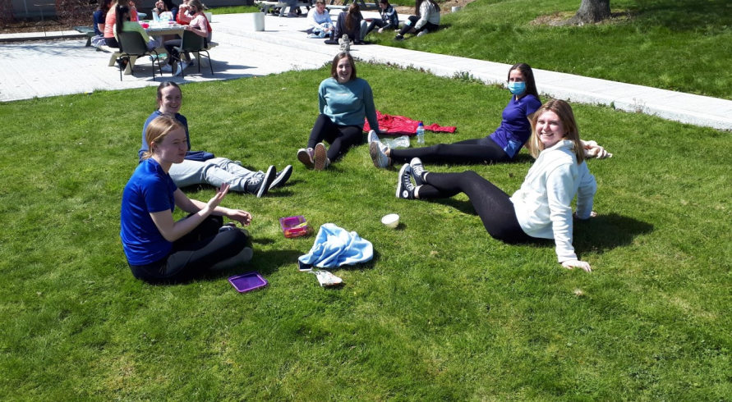

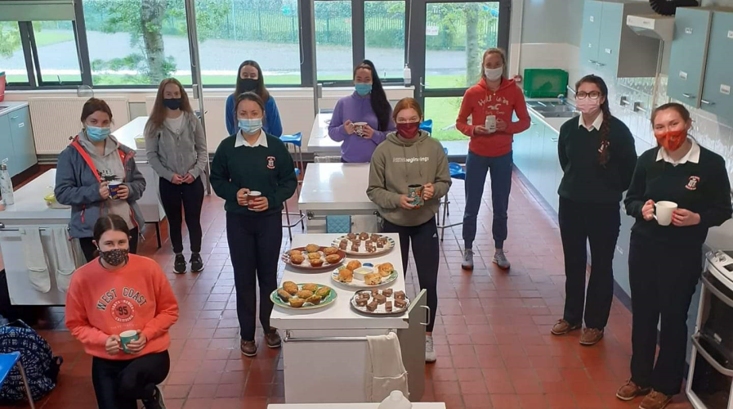

Student Council / Student Leadership / Student Voice

The Student Council operates under the guidance of Ms. O’Connell.

Scoil Mhuire Student Council is elected by the students of the school on an annual basis. The Head Girl and Deputy Head Girl are elected in May each year by the students of the Fifth Year group.

In the 2020-2021 school year the Head Girl was Ciara Fitzgerald-Cawdry and the Deputy Head Girl was Meg Henebry. Both students are commended for the leadership and care for their fellow students and were presented with a token of appreciation from the school at the outdoor Awards Ceremony on 26 May.

The Student Council participated in many activities and events throughout the school year including:

- Student Council elections and meetings every fortnight.
- Over 200 students purchased new PE top- designed by students themselves which led to greater buy in and a sense of ownership.
- Student Council involvement in LGBTQ+ Week.
- Collection for St. Vincent de Paul at Christmas as well as a virtual “sing along “which was fun for all.
- Student Council involvement in ‘Be Active’ Week.

The role of prefects was further developed by giving the prefects the responsibility of organising and encouraging girls in their classes to get involved in the ‘Spring into Action’ initiative and the live exercise classes during school closure.

During school closure, regular contact with the Student Council facilitated discussion of online issues and difficulties. Students were happy to know their issues were reported back to staff and improvements were noted. This was vital for student wellbeing during an exceedingly difficult time.

The Meitheal Programme providing support for 1st Year students was restricted in its operation this year but leaders made tremendous effort to encourage a sense of belonging, community and involvement among the First Year cohort. Student feedback was gathered at the end of the year and will inform modifications to the programme in the coming year.

Student Council and Meitheal leaders were encouraged to attend LIFT (Leading Ireland’s Future Together) roundtable events, and some continue to participate.

Students were encouraged to attend ISSU meetings.

Kendra Watson of TY, proposed and publicised the formation of a Youth Council for Carrick on Suir, to reflect the voice of young people and contribute to local development, facilities and resources for young people in the community. Kendra communicated with all local post-primary schools to recruit interested members.

All members of the Student Council attended the remote CEIST Student Gathering.

In-School Leadership & Management

Members of the In-School Management Team met with the Principal/Deputy Principal in May 2021for the annual reporting & review meeting which included discussion of:

- Review of progress in the role in 2020-2021
- Review of the role in light of School Needs
- Review of Professional Development
- Setting Objectives.

All post-holders submitted an annual report to senior management in advance of their individual meetings.

Following a number of retirements at the end of the 2020-2021 school year, there will be appointments to in-school leadership positions in September 2021.

School Attendance

Attendance was inevitably impacted by prevailing public health conditions during the school year. Statistics for the year are as follows:

Annual Attendance rate: 94%

Suspensions: 3 students

Exclusions: None

School - Community Links

Although in-person school visits were curtailed, many events and activities moved to the online space. Students availed of Third-Level Open Days remotely. Webinars and online presentations took place in the area of personal, social and health education. TY students attended the SHINE conference organised by the Shona Foundation. Outreach included fundraising at Christmas for the St. Vincent de Paul Society in Carrick on Suir, collections for care packages for the elderly and clothing collection for SVP.

Sixth Year Graduation

Fr. Patrick Cahill of Glencomeragh celebrated the Sixth Year Graduation Liturgy in St. Nicholas’ Church on Friday 28 May. Thanks to the 6th Year RE teachers Mrs. Shanahan, Mrs. O’Sullivan & Ms. Doran, Deputy Principal Ms. Guerin, the Music teacher Mrs. Sullivan and all 6th Years who participated in the preparation and livestream of the event. We wish the Class of 2021 every blessing and success as they move on from Scoil Mhuire.

Appreciation

The school community offers thanks to a number of staff members who have retired after careers of distinguished and committed service to our students and school.

Mr. Brendan O’Dwyer retired as School Principal in August 2020 having previously served as Deputy Principal and as a member of the Mathematics and Science Departments.
Mrs. Margaret Twohig retired in October 2020 from the Mathematics and Science Departments.

In 2021 we say farewell to the following teachers:

Ms. Carmel Donohoe, teacher of Mathematics.
Mrs. Daphne Dowley, teacher of Biology and Science.
Ms. Mary Greene, teacher of Business Subjects, IT and SPHE.
Mr. Fintan O’Mahony, teacher of English & History.

All of these teachers demonstrated a deep sense of care for their students in the classroom and through their many other roles in the delivery of co-curricular and extra-curricular activities to enrich teaching & learning in Scoil Mhuire. We wish them every blessing for happiness and fulfilment in the future.

Míle buíochas!

